Using Lego Spike Prime Sets to Teach Essential Coding Concepts Step-by-step Guide

Part 1: Aiming the Catapult

1. Go to the Lego Spike Website: <https://spike.legoeducation.com/>. Make sure you are using Google Chrome for your browser
2. Click on “Spike Prime”

1. For the first 2 sections of the workshop, students will build their own code from scratch. Click on “New Project”, then click on “Word Blocks” and “Create”.

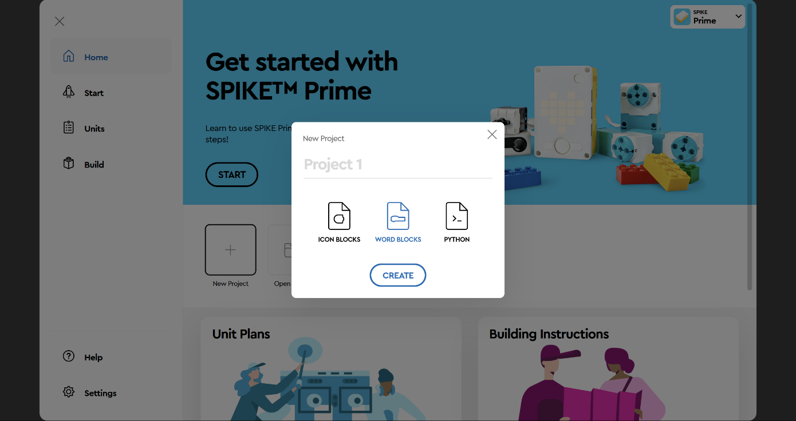

1. To connect to the main hub, click on “Connect”.
2. Grab your hub press the main button. If is updated click on “Green”, otherwise click on “White” to update and then come back to this step.

1. Make sure to turn on Bluetooth on your computer. Then press the Bluetooth button on the main hub located in the top-right corner.
2. Once Bluetooth is turned on for both devices, click on “Open”.
3. A screenshot of a computer

   Description automatically generated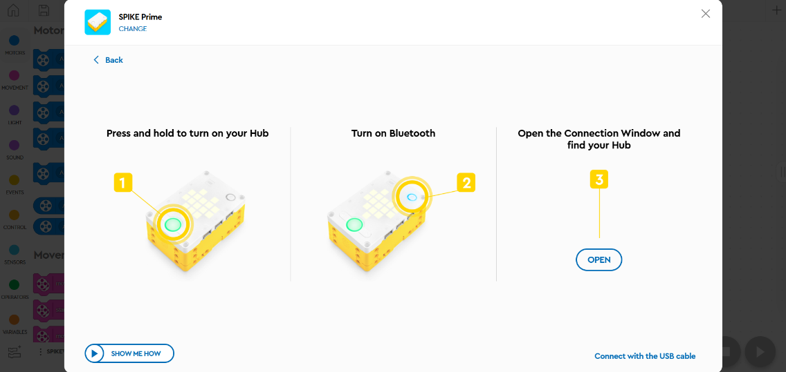On the pop-up window, select the hub and click on “Pair”.
4. To build the code for the first section, start by dragging a “set yaw angle to 0” block into the “when the program starts” event block. It is located under the sensors category.
5. 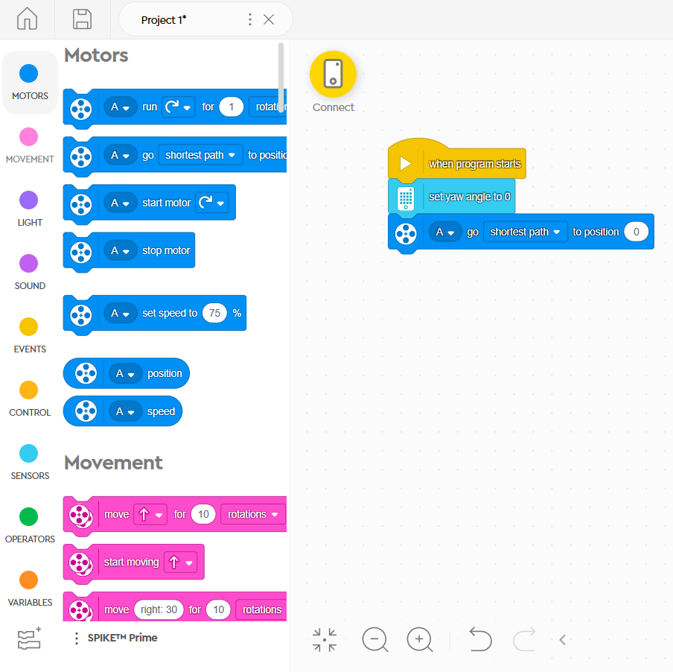A screenshot of a computer

   Description automatically generatedNext drag the first motor block to reset the direction. Drag a “go shortest path to position 0” block into the main event block. It is located under the “motors” category.
6. At this point make sure to connect all the components to the main hub (2 motors and 1 pressure sensor). Change the port letter on the motor block by clicking on the letter “A”, then select the letter that corresponds to the motor that aims the catapult (the one located at the base of the catapult)
7. Go to the “control” category and drag an “forever” loop block.

1. Drag another “go shortest path to position 0” block, this time inside the forever loop.
2. A screenshot of a computer

   Description automatically generatedMake sure the port letter matches the port used on the previous block.

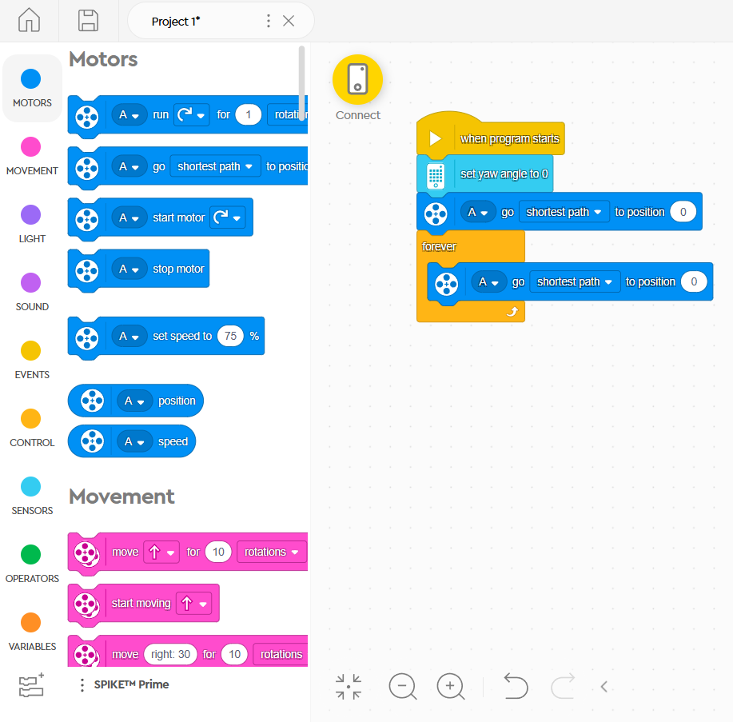

1. Go the “sensors” category and drag a “pitch angle” bubble into the “0” on the second motor block.
2. A screenshot of a computer

   Description automatically generatedClick on “pitch” and change it to “yaw” inside the bubble.

Part 2: Shooting the Catapult

1. To continue to the second part of the code, go to the “events” category and drag a “when pressed” event block into the workspace.
2. A screenshot of a computer

   Description automatically generated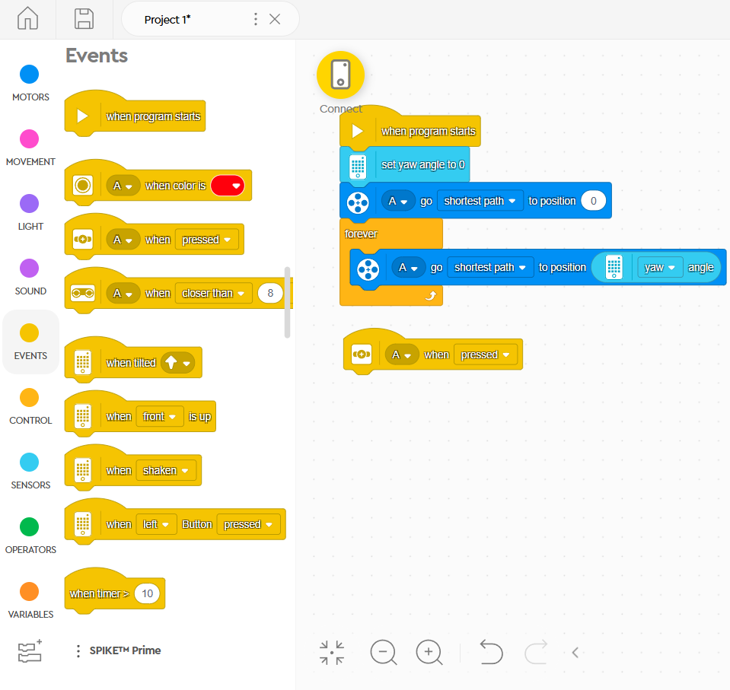Click on the port letter and change it. Make sure to use the one where the pressure sensor is connected.
3. Go to the “motors” category. Drag a “run clockwise for 1 rotations” block into the “when pressed” event block.
4. Change the port letter. Make sure to use the letter corresponding to where the motor at the top of the catapult is connected.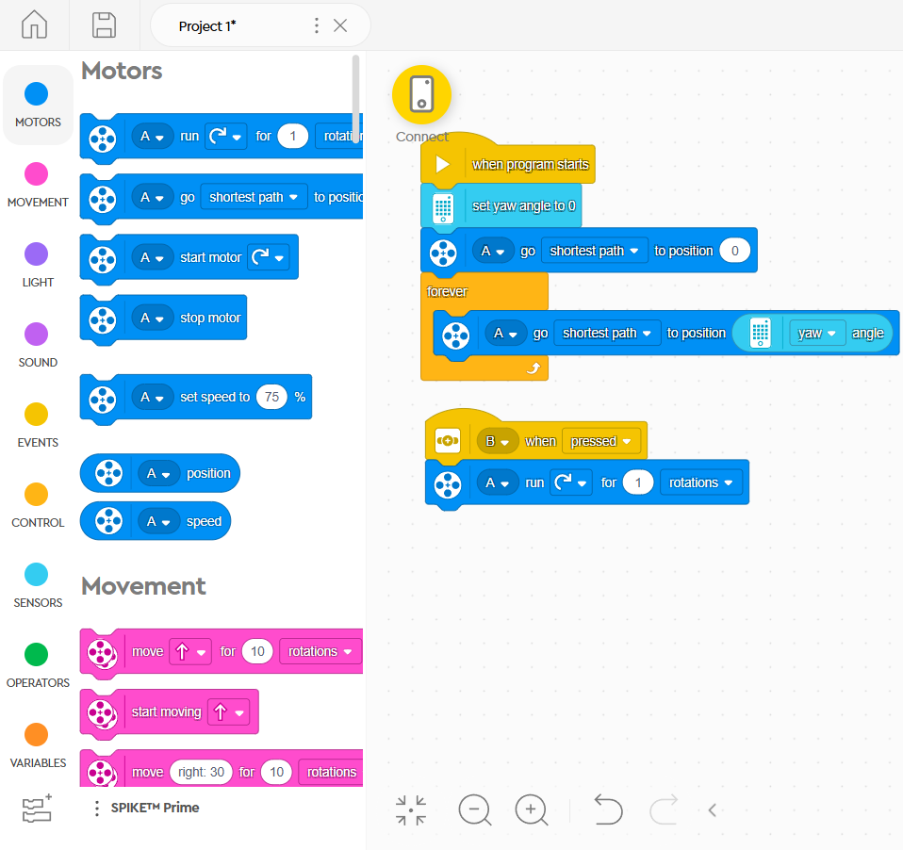A screenshot of a computer

   Description automatically generated
5. At this point students can start testing the catapults and shoot at targets. To start the code click on the start button on the bottom right of the workspace.

Part 3: Detecting Colors Using If-Statements

1. For the third section of the workshop, students will use an existing project and modify it. Go to the project’s GitHub and to the code folder of the repository.
2. A screenshot of a computer

   Description automatically generatedDownload the “IfStatementBasic.llsp3” file.

1. Go back to the Spike Prime website. Click on “Open Project” this time.
2. A screenshot of a computer

   Description automatically generatedGo to the downloads folder and open the file.

1. Click on “Save changes” if you want to save the modifications to the code.

1. Go to the color sensor event blocks. Make sure to change the pressure sensor with the color sensor. Change the port letter to the where the new sensor is connected. Repeat for each one of the event blocks.
2. Give each team 3 Lego blocks of different colors. Change the detected colors of the events blocks to match those 3 Lego blocks.

1. Type the name of each color inside of the “set Target to” block. Make sure to match that with the color the event block is detecting.
2. A screenshot of a chat

   Description automatically generatedGo to the “Throw” function block. Type those same colors inside each one of the If-statement blocks.

1. Change the angle of each one of the motor blocks inside each if-statement. Dragging the arrow on the wheel helps you visualize the direction the motor will aim at.
2. A screenshot of a computer

   Description automatically generatedA screenshot of a computer

   Description automatically generatedWe suggest starting with 0, 45, and 315 degrees to shoot forward, right, and left respectively. You can adjust these numbers to aim at your specific targets.
3. Before testing the code, make sure to change each one of the motor blocks to use the correct letter port. Blocks with the port “C” correspond to the motor that aims the catapult, located at the base. Blocks with the port “E” correspond to the motor that shoots, located at the top of the catapult. You may also plug in these two motors to ports “C” and “E” to match the existing code.

1. Click on the play button to test the code. Show a color to the sensor to the catapult aim and shoot at the corresponding target.

